**CIS-310 Database Design**

**Assignment #7**

**40 points**

Student Name: Mikhaela Mueller

After you have successfully completed Assignment 4, the Premiere Products database containing five tables (REP, CUSTOMER, ORDERS, PART, and ORDER_LINE) populated with the data and the entity relationship diagram (ERD) should already be in your SQL Server account. You will also find the five database tables at the end of this document.

IMPORTANT NOTE: Several students in the class have not submitted Assignment 4. These students have to run the script given in Assignment 4 to create and populate the Premiere Products database and the ERD now to be able to complete this Assignment (due by Sun, Oct 24). See the Assignments/Assignments/Assignment 4 folder. In Assignment 7 you will be working with the same Premiere Products database again.

Using the Premiere Products database write the SQL queries for the following problems. Save the eight queries in a single SQL file or in eight separate files in your account on J drive. Paste your queries and the outputs they generated after each of the eight problems.

After you paste the queries and the output save this document as Word or pdf file named Assignment7_YourFirstName_YourLastName and submit via Blackboard. See the Assignments/Assignments/Assignment 7 folder.

Problem 1. List all rows and columns for the complete ORDERS table. Paste the query and the output below.

SELECT ORDER_NUM, ORDER_DATE, CUSTOMER_NUM

FROM ORDERS;

|  |  |  |  |
| --- | --- | --- | --- |
|  | ORDER_NUM | ORDER_DATE | CUSTOMER_NUM |
| 1 | 21608 | 2020-10-20 00:00:00:000 | 148 |
| 2 | 21610 | 2020-10-20 00:00:00:000 | 356 |
| 3 | 21613 | 2020-10-21 00:00:00:000 | 408 |
| 4 | 21614 | 2020-10-21 00:00:00:000 | 282 |
| 5 | 21617 | 2020-10-23 00:00:00:000 | 608 |
| 6 | 21619 | 2020-10-23 00:00:00:000 | 143 |
| 7 | 21623 | 2020-10-23 00:00:00:000 | 608 |

Problem 2. List the part number and part description of each part that is not in item class AP. Paste the query and the output below.

SELECT PART_NUM, DESCRIPTION

FROM PART

WHERE CLASS = ‘HW’

OR CLASS = ‘SG’

|  |  |
| --- | --- |
| PART_NUM | DESCRIPTION |
| AT94 | Iron |
| BV06 | Home Gym |
| DL71 | Cordless Drill |
| FD21 | Stand Mixer |
| KV29 | Treadmill |

Problem 3. List the part number, description, and number of units on hand for each part that has between 10 and 25 units on hand, including both 10 and 25. We can do this in two ways. Paste the query and the output below.

SELECT PART_NUM, DESCRIPTION, ON_HAND

FROM PART

WHERE ON_HAND >= 10

AND ON_HAND <=25;

|  |  |  |
| --- | --- | --- |
| PART_NUM | DESCRIPTION | ON_HAND |
| DL71 | Cordless Drill | 21 |
| DW11 | Washer | 12 |
| FD21 | Stand Mixer | 22 |
| KL62 | Dryer | 12 |

Problem 4. List all details about all parts. Order the output by part description. Paste the query and the output below.

SELECT *

FROM PART

ORDER BY PART DESCRIPTION

|  |  |  |  |  |  |
| --- | --- | --- | --- | --- | --- |
| PART_NUM | DESCRIPTION | ON_HAND | CLASS | WAREHOUSE | PRICE |
| DL71 | Cordless Drill | 21 | HW | 3 | 129.95 |
| KT03 | Dishwasher | 8 | AP | 3 | 595.00 |
| KL62 | Dryer | 12 | AP | 1 | 349.95 |
| DR93 | Gas Range | 8 | AP | 2 | 495.00 |
| BV06 | Home Gym | 45 | SG | 2 | 794.95 |
| AT94 | Iron | 50 | HW | 3 | 24.95 |
| CD52 | Microwave Oven | 32 | AP | 1 | 165.00 |
| FD21 | Stand Mixer | 22 | HW | 3 | 159.95 |
| KV29 | Treadmill | 9 | SG | 2 | 1390.00 |
| DW11 | Washer | 12 | AP | 3 | 399.99 |

Problem 5. List the part number, part description, and on-hand value of each part whose number of units on hand is more than the average number of units on hand for all parts. (Hint: Use a subquery or a nested query.). Paste the query and the output below.

SELECT PART_NUM, DESCRIPTION, ON_HAND

FROM PART

WHERE ON_HAND > (SELECT AVG(ON_HAND) FROM PART);

|  |  |  |
| --- | --- | --- |
| PART_NUM | DESCRIPTION | ON_HAND |
| AT94 | Iron | 50 |
| BV06 | Home Gym | 45 |
| CD52 | Microwave Oven | 32 |
| FD21 | Stand Mixer | 22 |

Problem 6. What is the part number, description, and price of the least expensive part in the database? (Hint: Use a subquery, a nested query.). Paste the query and the output below.

SELECT PART_NUM, DESCRIPTION PRICE

FROM PART

WHERE PRICE = (SELECT MIN(PRICE) FROM PART);

|  |  |  |
| --- | --- | --- |
| PART_NUM | DESCRIPTION | PRICE |
| AT94 | Iron | 24.95 |

Problem 7. List the sum of the balances of all customers for each sales rep. Order and group the results by sales rep number. Paste the query and the output below.

SELECT BALANCE, REP_NUM

FROM CUSTOMER

WHERE BALANCE = (SELECT SUM(BALANCE) FROM CUSTOMER);

ORDER BY CUSTOMER REP_NUM;

|  |  |
| --- | --- |
| BALANCE | REP_NUM |
| 30000.00 | 20 |
| 27500.00 | 35 |
| 27500.00 | 65 |

Problem 8. For each part, list the part number, description, units on hand, order number, and number of units. All parts should be included in the results. For those parts that are currently not on order, the order number and number of units ordered should be left blank. Order the results by part number. Paste the query and the output below.

SELECT PART_NUM, DESCRIPTION, ON_HAND, ORDER_NUM, NUM_ORDERED

FROM PART, ORDER_LINE

WHERE PART.PART_NUM = ORDER_LINE.PART_NUM;

ORDER BY PART_NUM

|  |  |  |  |  |
| --- | --- | --- | --- | --- |
| PART_NUM | DESCRIPTION | ON_HAND | ORDER_NUM | NUM_ORDERED |
| AT94 | Iron | 50 | 21608 | 11 |
| BV06 | Home Gym | 45 | 21617 | 2 |
| CD52 | Microwave Oven | 32 | 21617 | 4 |
| DL71 | Cordless Drill | 21 |  |  |
| DR93 | Gas Range | 8 | 21619 | 1 |
| DR93 | Gas Range | 8 | 21610 | 1 |
| DW11 | Washer | 12 | 21610 | 1 |
| FD21 | Stand Mixer | 22 |  |  |
| KL62 | Dryer | 12 | 21613 | 4 |
| KT03 | Dishwasher | 8 | 21614 | 2 |
| KV29 | Treadmill | 9 | 21623 | 2 |

PREMIERE PRODUCTS SCHEMA

TABLE REP

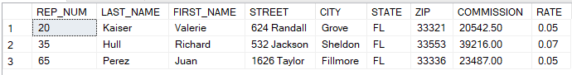

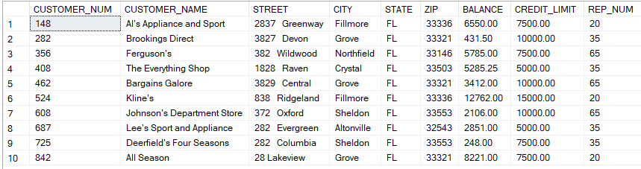TABLE CUSTOMER

TABLE ORDERS

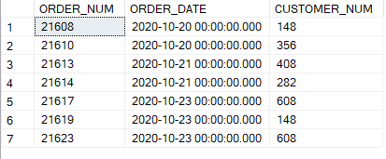

TABLE PART

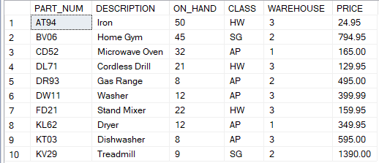

TABLE ORDER_LINE

